Annual Resident Participation Report April 2023 - March 2024
Residents Panel 25th April 2024

- Purpose of the report
1.1 To provide the Residents Panel with an update on Resident Participation at North Wales Housing (NWH) from April 2023 to March 2024.

2 Background
2.1 Resident Participation occurs when social landlords share information, ideas
and decision making with residents.

3 Introduction
3.1 Our participation work for this reporting period is based on our Resident
Participation Strategy for 2021 - 2024.The Strategy was developed following a
consultation to gather the views of residents and staff.

3.2 This report sets out what resident participation opportunities are available and what activities have taken place from April 2023 to March 2024.

4 Residents Panel
4.1 The Panel consists of Board members, residents, and staff, and meets every two
months. It has the responsibility for scrutinising our services and performance to
ensure all residents receive the highest possible standards of service. The Panel and
its resident members are also a key part of the governance of NWH.

4.2 During this reporting period Panel members have received training and participated in workshops facilitated by TPAS Cymru. Topics have included:
- A Brief Introduction to Housing Associations
- Resident Involvement – Why? And the Benefits
- The Regulatory Framework for Housing Associations in Wales
- Equality and Diversity

4.3 Members have also attended TPAS network meetings with residents from other social landlords.

5 Residents Forum
5.1 The Forum is a less formal setting for residents to attend. Its aim is to provide an
opportunity to obtain information, influence decision making, and strengthen services.
A meeting is dedicated to a particular topic, allowing members to learn more
about NWH, and provide input and feedback to improve the services we provide.

5.2 The Forum meets every two months. The Forum meets online in the evenings to
hopefully make it more accessible to more residents.

5.3 What has the Resident Forum done since April 2023

What has the Residents Forum done | Difference Made/ You Said We Did
TP Strategy & Action Plan | The final document should be more visual and more accessible with less text -This will be reflected in the final version and a designer will be used to help us achieve this.
Service Charges Review | Service Charge Leaflet – Need to ensure its clear and understandable. No jargon - This was reflected in the final version and the feedback from wider residents were positive and confirmed it was understandable.  Service charge consultation plan – Commented there should be a variety of options to participate. Some people may be in work or not in during the door knocking and scheme visits. Residents were given an option to complete a postal survey, by email, and phone calls.  The Forum received regular updates on the progress of the Review.
Customer Portal Review | One of the Forum members participated in the review of the new Portal with Resident Panel members.
Customer Care Charter | Reviewed draft version - Commented on some typos which have been corrected. Said the charter should be widely shared with residents and staff. There’s a danger it could be meaningless unless it is followed by staff - There will be a campaign to raise awareness with staff and residents.
Complaints Leaflet | Members of the Forum attended a focus group facilitated by Tai Pawb as part of the QED project. Members commented that the text was too small and could the amount of text be reduced - Re-designed leaflet with larger text. The content of the leaflet uses text from the new complaints procedure. The Forum were satisfied with the new version.
Reviewed Draft Policies | Equality, Diversity & Inclusion Policy  Income Policy  Repairs Policy  The Forum had no concerns regarding these documents but would welcome the opportunity to view more when necessary. Confirmed with the Forum this can be arranged.

5.4 A quote from a Forum member – Joining the group has given me a much better
understanding of how the association works, and how we might improve on some issues.
It is an opportunity to share views, opinions and be a little proactive in the topics that are
brought to the group.

6. Sounding Board
6.1 The Sounding Board is a database of tenants who are interested in acting as a
‘reader of leaflets’, forms, policies etc. and providing feedback. There are 32 members,
and they were involved in the following arears of work during this reporting period:
- Reviewed draft repairs policy and equality, diversity & Inclusion policy
- 2 Members attended the Tai Pawb focus group which included providing the
feedback on our complaints leaflet. All members sent final version of leaflet to
review.
- 3 Members attended the Corporate Plan workshop
- All surveys (e.g. Corporate Plan consultation and Resident Participation Strategy Consultation) sent to members to complete

6.2 We need to further utilise this group and offer more opportunities for them to provide
input and feedback.

7 Rent Service Charge Review
7.1 Concerns had been raised and poor feedback about service charges, as well as low
satisfaction levels in the star survey brought about a review of our service charges.
Negative feedback also included a lack of understanding about services charges and
what they covered.

7.2 A new service charge pamphlet created following with input from The Residents Panel
and Forum. A consultation plan for the service charge review also received input from
the Panel and Forum. Key priority from Panel and Forum members were to ensure there
were different options to take part.

7.3 2141 residents pay a service charge. 1026 completed the survey. Completion rate of
48%, or 51% if we ignore agency managed schemes and properties, we were unable to
consult with e.g. resident in hospital, prison, or void property.

7.4 The Survey included a question about the new service charge leaflet – After reading the
service charge pamphlet and sheet, do you understand what you’re paying for?

Response | Number of Responses
Yes | 997
No | 27
Didn’t answer | 2

7.5 Difference Made/You Said We Did
- Residents valuable feedback about other matters such as litter, communal areas, skip days, repair requests, and referrals or financial wellbeing support. Comments were shared between relevant teams to action.
- Comments were made about wanting NWH to be more visible
- We now have a calendar of events on schemes to makes us mor visible. It’s now an action to have at least 1 event per month. These include community days and scheme clean ups in response to concerns about litter, fly tipping, and general appearance of schemes. These events can also assist us in being more visible.
- Significant dissatisfaction recorded on cleaning in communal area areas. Cleaning has just been brought in-house rather than using a contractor. This will hopefully bring about improvement.
- 5% said service charges were unaffordable – The Income Team contacted have contacted these residents to provide support and guidance.
- Survey results also showed residents have a greater understanding of what they’re paying for.
- Majority of respondents confirmed service charges were affordable.
7.6 Quote from one of the participants - Brilliant to see NWH are transparent and take on
board tenant option and actually take action. Well done!

8 Corporate Plan consultation
8.1 In developing the new Corporate Plan we wanted to share our ambitions for NWH for
the next 3 years with our residents and also hear their views and what is important to
them.

8.2. Also, when communicating with our residents and conducting our day-to-day business
we wanted to ensure some consistency in what we call our residents or tenants. In
the consultation we asked for a preference from:
- Client
- Contract Holder
- Customer
- Resident
- Tenant

8.3 A survey was sent out by text message, social media, and sent out to our Sounding
Board members. Those who completed the survey were asked if they would like to hear
more about the corporate plan, and they were invited to attend a workshop to receive
an update on how their feedback has been used in developing the Corporate Plan. 225
survey responses were received, and 7 residents attended the workshop.
8.4 Difference Made/You Said We Did
- The majority of responses agreed with our ambitions for the next 3 years
- Key priorities were for residents were good communication, listening and acting on feedback, and getting the basic services right. These are now main themes in our new Corporate Plan and will be reflected in the Action Plan to carry out its aims.
- The majority of responses confirmed the term they preferred best was resident. We are now using the term resident.
- The residents who attended the workshop were able to hear how all the feedback was used and also have a preview of the new Corporate Plan

- Resident Participation Strategy Consultation
  - In recent months we have been working on developing our new Resident Participation. Why have a Strategy? It sets out our commitment to having effective consultation; helps us improve our services; and it’s a regulatory requirement.

  - In developing the Strategy, we have consulted with our residents. A survey was sent out by text message, social media, and sent out to our Sounding Board members. We also used our events as an opportunity to listen to resident views. 219 survey responses were received.

  - Difference Made/You Said We Did
- The majority of respondents were satisfied with the options available to participate. We will continue to support these options; however, we will be looking at ways to make them more accessible and raise further awareness so that we can increase involvement levels.
- Good communication was seen as a priority. We will be relaunching the resident newsletter and look at other ways to raise awareness of resident participation and the difference it makes.
- Being visible was very important to residents. Improving the visibility of NWH will be a key aim of the new Strategy.
- There were comments about the service charges consultation and how positive it was to have door knocking, face to face opportunities, but also other options to participation too such as phone and email. When consulting with our residents we will provide a variety of options to participate. One of the aims of the Strategy will be to provide meaningful involvement options so that residents can influence decision making.
10 Customer Portal Review
10.1 In the previous reporting period residents were involved in choosing our new
housing management system supplier. A workshop was arranged for March 2024 to
give interested residents the opportunity to have a look at the Portal. Although all of the
functionality is not yet built, the session was primarily for them to review the look and
feel, and usability. Participants were able to log in via pc, tablet and mobile to a play
about with the system. On usability it was confirmed by participants as easy to navigate
and a good layout.

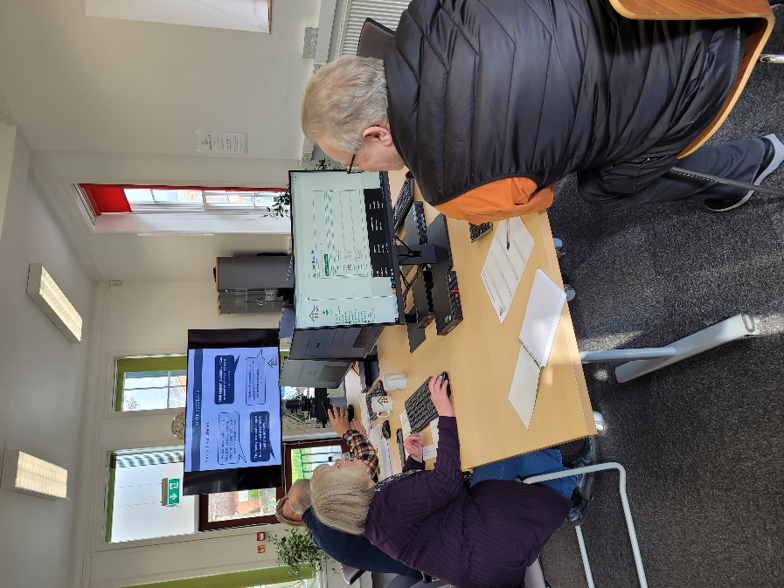

- Events and activities
11.1 We organise events and activities to engage with our residents. They can be an
opportunity to listen to resident views and undertake any necessary consultations. The
Neighbourhood Team collaborate with the Customer Experience Team to deliver to
deliver a lot of the events below, with often other colleagues such as from the Income
Team attending to engage with residents.

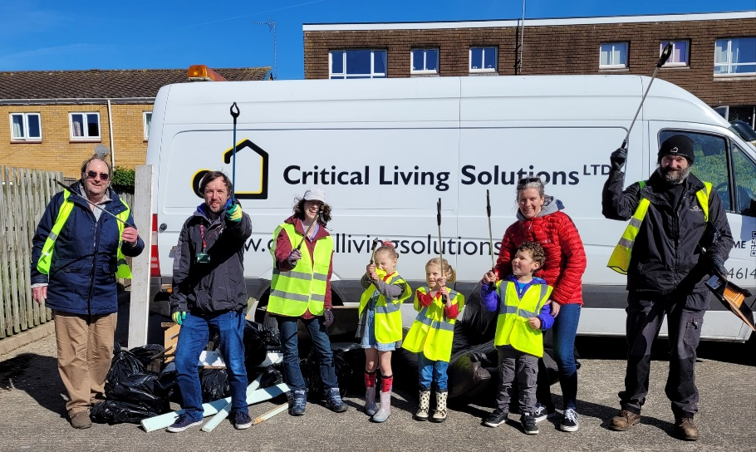

April 2023 | Parc Clarence (Craig y Don, Llandudno) Community Litter Pick
May 2023 | Colwyn Bay Pride Event
June 2023 | Woodlands (Llandudno Junction) Community Day
July 2023 | Cae Bold (Caernarfon) Community Day
August 2023 | Bryn Felin/Bryn Awel/Cilfan (Conwy) Community Day  Colwyn Bay Big Picnic
September 2023 | Llawr y Nant Seed Planting & Art Activities (Bethesda)
October 2023 | Maesgeirchen Halloween Event
November 2023 | Bron Bethel (Rachub) Community Day
December 2023 | Online Corporate Plan Preview for residents  Llain Cytir (Holyhead) Christmas event/drop in
January 2024
February 2024 | Cae Mawr (Llandudno) Community Day  Maesgeirchen Environmental Day
March 2024 | Maesgeirchen Easter Event  Ffordd Dawel & Heol Dirion (Colwyn Bay) Community Day  Customer Portal Resident Workshop (Plas Blodwel)

*Residents commented on the recent Ffordd Dawel & Heol Dirion Community Day that it was the first time in a long time they had seen residents outside mixing outside talking and enjoying each other’s company.

11.3 Our Rakes & Ladders Team create opportunities to engage with residents, for
example they recently collaborated with the Neighbourhood Officer and residents at
Arafa Don (Bethesda) to enhance the area. Along with the residents they identified
areas in need of attention and cleared away the moss and greenery from the front
area of the building. Residents were then able to choose which plants they would like
and then did some planting.

11.4 The Older Persons Team were successful in delivering the following activities and
projects:
- Digital Inclusion Projects
- Numerous Fundraising Events
- Exercise Classes
- Regular Tenants Newsletters
- Gardening Projects
- Celebration Parties and Entertainers
- Coffee Mornings and Afternoon Teas
- Invited Speakers to Schemes
- Residents Meetings
- Indoor Bowling
- Welfare visits
- Financial Inclusion
- Arts & Crafts
- Dementia Actif Gwynedd sessions
- Bridging the Generations project – visits from local primary school pupils to participate in activities with the residents.
- Falls Prevention Sessions
- Activities in connection with the Communities ie Merched y Wawr, Clwb y Garnedd, U3A, Ukelele Club,
- Community Safety Sessions
- Hearing Aid Clinics
- Information & Advice Events
11.5 The Supported Housing Team continued to provide a variety methods to engage with
Residents
- Calendar of Events & Activities provided to each resident within the scheme
- House meetings for residents to discuss any issues or concerns they may have. It also provides residents an opportunity to share any achievements / successes they’ve had during the week
- Cooking on a Budget sessions where residents cost up the ingredients for a dish, then prepare and cook it
- Residents participating in gardening at all the hostels
- Budgeting and planning skills
- Film nights
- Quiz nights
- Arranged walks
- Conwy Youth Service sessions
- Pool Competition
- Fitness sessions
- 5 aside football

12 e-Cymru
12.1 NWH is working in partnership with other landlords to provide an online platform called
e-Cymru. e- Cymru is a platform that offers free events, engagement, and e-learning
opportunities. It’s free to all NWH residents to use (and the residents of the partner
landlords in the project). We will further promote the availability of the platform and the
opportunities it provide to our residents.

13 Internal Audit
13.1 In October 2023 we commissioned an audit on our formal resident participation
opportunities. The result of the audit was pleasing with a substantial level of assurance.
The independent auditors said -

NWH has a sound system of internal control in place with regards to resident
engagement. A number of good practice areas were noted, including strong
governance arrangements, strategies, and actions to improve resident
participation and evidence of resident feedback being utilised for strategic decision
making and operational performance monitoring.

We identified that improvements could be made to formalise arrangements around
induction and training for resident members. It is noted that management are aware of
this area for improvement and work is ongoing to provide resident members with
relevant training.

  - The following recommendations (which has been described as low in risk) were
made:
- We recommend induction arrangements for new tenants who join participation groups are formalised and documented to ensure all relevant areas are communicated.
- We recommend processes are established to evaluate and identify gaps in the knowledge and experience of tenant members to provide relevant training where necessary.

  - This has been reflected in the development of our new Participation Strategy with
one of the aims being to Increase the skills and knowledge of residents.

14 Star Survey Results
14.1 The Star Survey is an annual Resident Satisfaction Survey carried out in November
and December every year. We saw significant progress in the areas relating to
Resident Participation: however we recognise there is further room for improvement.

2023 2022 Wales
Listens to views and acts on them | 76% | 69% | 66%
Taking part in decision making | 66% | 63% | 60%
Having a say in the way services are managed | 78% | 63% | 60%

15 TPAS Awards
15.1 At the TPAS Good Practice Awards in 2023 our project involving residents in selecting
a new housing management system supplier achieved 3rd place in the Involving
Residents in Shaping Services Category.

16 Future Actions
16.1 Implement the new Resident Participation Strategy and Action Plan.

16.2 More community days and develop further and different type of events and activities to
engage with our residents.

16.3 This report will be translated and published on our website. It will also be made more
accessible and visual for residents to view and hold us to account.

